**OUTREACH SCHOOLS EXAMINATION BOARD**

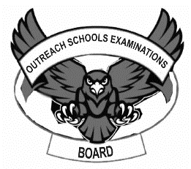**MID TERM III EXAMINATION 2023**

**BABY CLASS: (3 – 4 YEARS)**

**LEARNING AREA 5: LANGUAGE DEVELOPMENT II**

**My name is: ……………………………………………………………….**

**My School is: …………………………………….………………………..**

**I am in: ………………………………..…………………………….…………………..**

I. **Match a vowel to the friend and draw.**

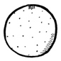a __________

e __________

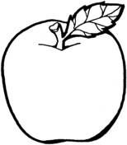i __________

o _________

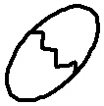u __________

2. **Circle the correct vowels for the picture**.

|  |  |
| --- | --- |
| D:\Local Disk F\New folder\KIBUUKA 2023\pictures\kibuuka pic\egg.jpg | i e |
|  | u o |
|  | e a |
| D:\Local Disk F\New folder\KIBUUKA FOLDER\images\DISAN PICS\pics\ink pot s.png | u i |
| D:\new images\Food\nion.bmp | o a |

3. **Form words and read.**

i-t = ___________

a -n = ___________

i-n = ____________

o-n = ____________

a-m = ___________

4. **Read the words.**

an at it

5. **Shade this animal for sound s.**

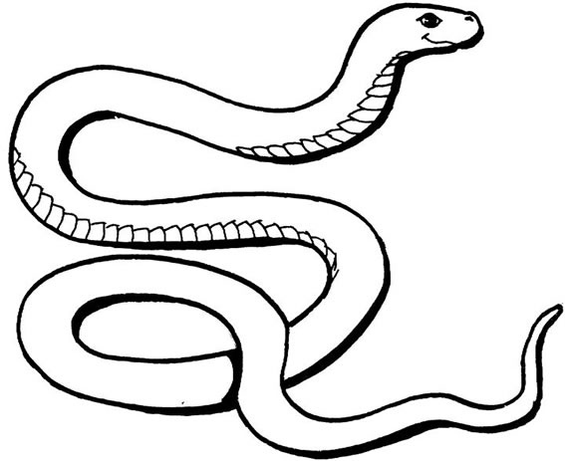

6. **Copy and write**.

|  |
| --- |
| m m m m m |
|  |
|  |
|  |
|  |
| t t t t t |
|  |
|  |
|  |
|  |
|  |
| r r r r r |
|  |
|  |
|  |
|  |

**END**